Assignment No. 01: What is Networking



Spring 2025
CSE-303L Data Communication and Networks Lab

Submitted by: Naveed Ahmad
Registration No.: 22PWCSE2165
Class Section: B

“On my honor, as a student at the University of Engineering and Technology, I have neither given nor received unauthorized assistance on this academic work.”

Student Signature: ______________

Submitted to:

Dr. Ihsan Ul Haq
April 08, 2025

Department of Computer Systems Engineering
University of Engineering and Technology, Peshawar
Oodeded

A

MODULE 01:
Task 01:OSI MODEL:

- Which layer is responsible for end-to-end communication between running applications?
- 4

- Which layer is responsible for routing packets to the proper network?
- 3

- In the OSI model, which layer is responsible for encoding the application data?
- 6

- Which layer is responsible for transferring data between hosts on the same network segment
- 2

TASK 02: TCP/IP MODEL:

- To which layer does HTTP belong in the TCP/IP model?
- Application layer

- How many layers of the OSI model does the application layer in the TCP/IP model cover?
- 3

TASK 04: IP ADDRESS AND SUBNETS:

- Which of the following IP addresses is not a private IP address?
- 9.69.147.197
- Which of the following IP addresses is not a valid IP address?
- 192.168.305.19

TASK 05:UDP AND TCP:

- Which protocol requires a three-way handshake?
- TCP
- What is the approximate number of port numbers (in thousands)?
- 65

TASK 06:ENCAPSULATION:
- On a WiFi, within what will an IP packet be encapsulated?
- Frame
- What do you call the UDP data unit that encapsulates the application data?
- Datagram
- What do you call the data unit that encapsulates the application data sent over TCP?
- Segment

TASK 06:Telnet:
- Use telnet to connect to the web server on. MACHINE_IP What is the name and version of the HTTP server?
- lighttpd/1.4.63
- What flag did you get when you viewed the page?
- THM{TELNET_MASTER}

Task 08: Conclusion:

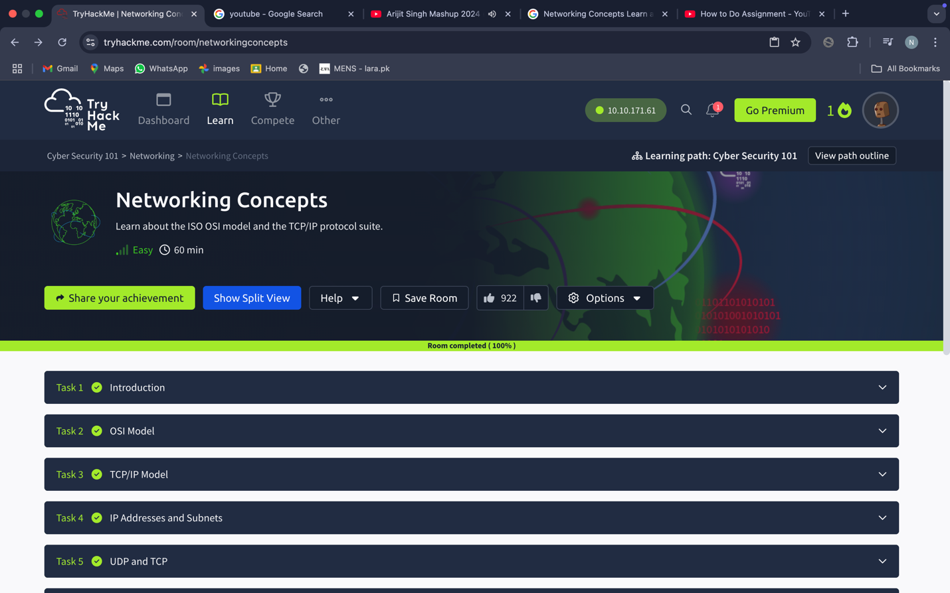

MODULE 02:

TASK 01: WHAT IS NETWORKING:
- What is the key term for devices that are connected together?
- Network

TASK 02: WHAT IS INTERNET:
- Who invented the World Wide Web?
- Tim Berners-Lee

TASK 03: IDENTIFYING DEVICES ON A NETWORK:
- What does the term “IP” stand for?
- Internet Protocol
- What is each section of an IP address called?OctetHow many sections (in digits) does an IP address have?
- 4
- What does the term “MAC” stand for?
- Media Access Control
- Deploy the interactive lab using the “View Site” button and spoof your MAC address to access the site. What is the flag?
- THM{YOU_GOT_ON_TRYHACKME}

TASK 04: PING(ICPM):
- What protocol does ping use?
- ICMP
- What is the syntax to ping 10.10.10.10?
- ping 10.10.10.10
- What flag do you get when you ping 8.8.8.8?
- THM{I_PINGED_THE_SERVER}

TASKS COMPLETION:
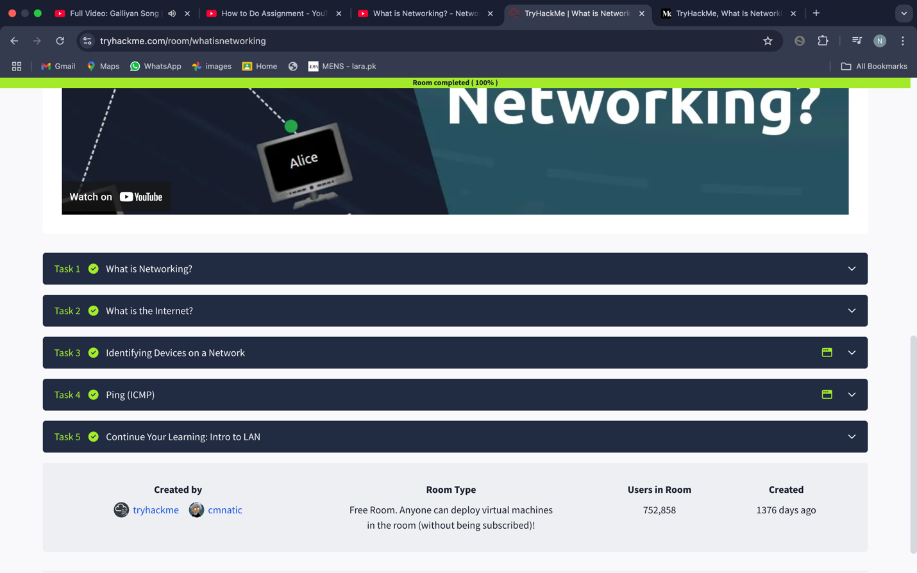

Profile:
